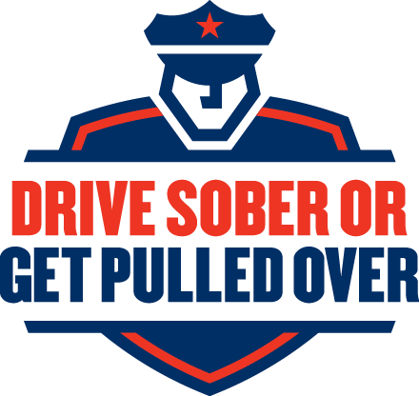

2023 AUGUST/LABOR DAY DRIVE SOBER OR GET PULLED OVER

FOR IMMEDIATE RELEASE: 08/11/2023

NHTSA and Local Law Enforcement Remind Drivers:

Drive Sober or Get Pulled Over
Madison County, NE— During the Labor Day holiday period, including the end of summertime and the busy holiday weekend, the U.S. Department of Transportation’s National Highway Traffic Safety Administration (NHTSA) will be working alongside the law enforcement community in
Madison County Area to decrease impaired driving. From August 18 through September 4, Madison County Sheriff Department will be participating in the Drive Sober or Get Pulled Over high-visibility enforcement period. In support of the law enforcement community’s dedication to protecting the lives of residents in their communities, you will see officers working together during this time to take drunk drivers off the roads. No matter how you plan to celebrate the end of summer this year, make sure you plan to do it safely.

Madison County Sheriff Department will be conducting a High-Visibility Check-Point on September 1, 2023 starting at 7pm. This will be conducted south of Norfolk on 556 Avenue (South 1st Street). The location will be between Sherwood and Monroe.

No one should mix drinking and driving, and no one is immune to the effects of drinking. If you find yourself intoxicated, or “buzzed” and stranded with your vehicle, give your keys to a sober driver who can safely drive you home. Remind your friends never to get into a vehicle with a drunk driver. If you have a friend who is about to drive after drinking, take away their keys and help them get home safely. Most importantly: Always have a plan before you head out for the evening. If you wait until after you have been drinking to figure out how to get from one place to the next, you will already be too impaired to make the right choice.

For more information on impaired driving, visit www.nhtsa.gov/risky-driving/drunk-driving.
Sheriff Todd Volk
###

